

**Artificial Intelligence Lab 06 Tasks**

**Name:** Maham Bibi

**Sap ID:** 45652

**Batch:** BSCS-6th semester

**Lab Instructor:**

Ayesha Akram

**Tasks**

**Task 1:**

Consider 2-d array andConvert all the elements of a numpy array from float to Bool datatype.

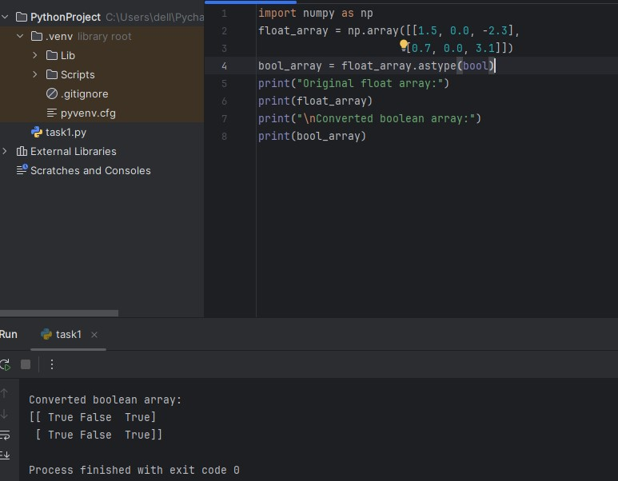

**Task2:**

Write a Python program that uses insert function to add an element to a specific position in a array.

* add the element 55 at position 2.
* **Print the updated array after the insertion.**

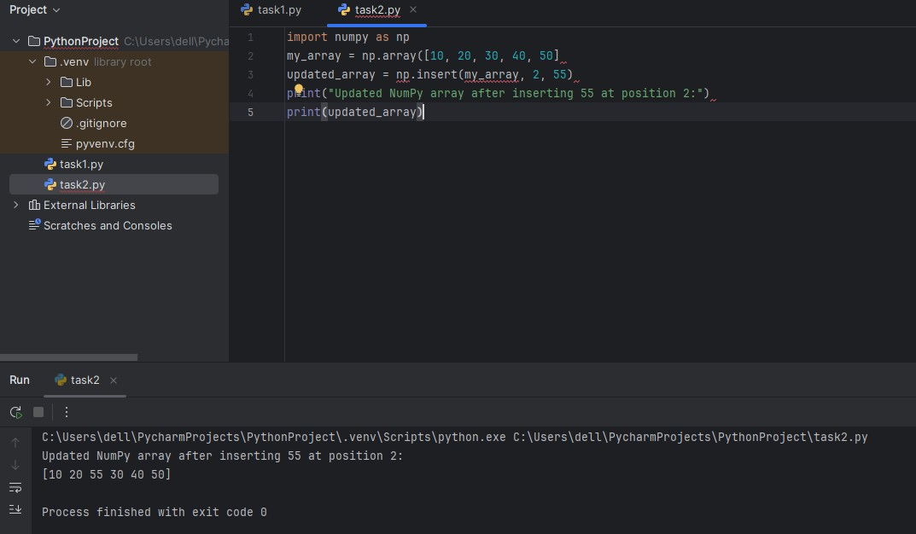

**Task3:**

Generate a sequence of numbers in the form of a numpy array from 0 to 100 with gaps of 2 numbers, for example: 0, 2, 4

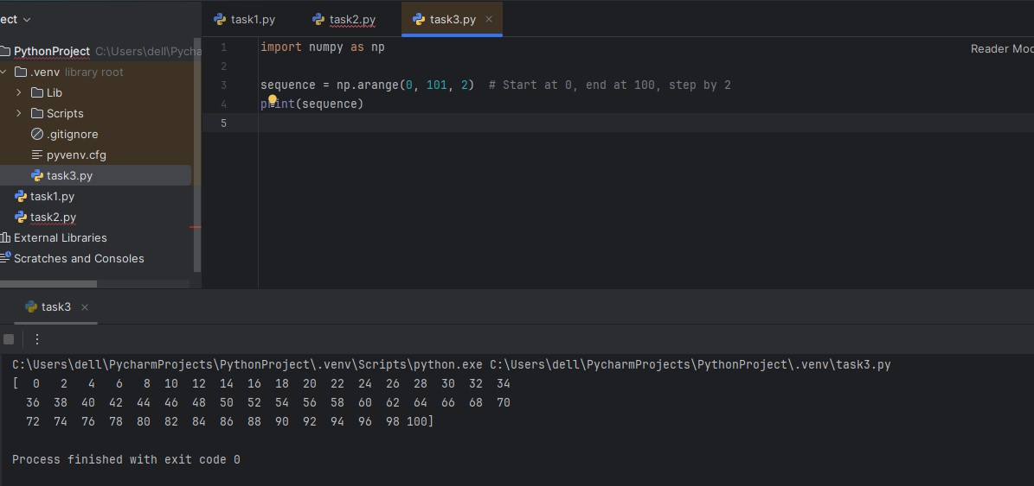

**Task 4:**

Given 2 numpy arrays as matrices, output the result of multiplying the 2 matrices as a numpy array

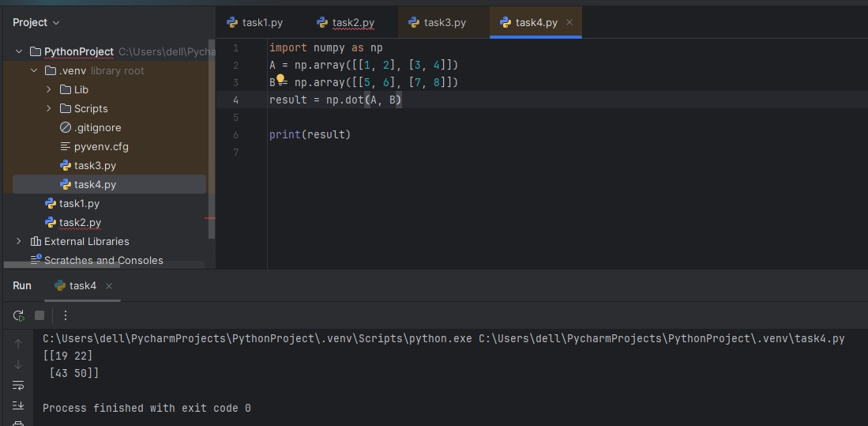

**Task5:**

Consider a 1-d array and check whether the specific number is present or not?

